FRAGILE OR THE PARABLE OF THE ANGELUS NOVUS
Under the title Fragil oder die Parabel vom Angelus Novus (Fragile or the Parable of the Angelus Novus), the Passages project series under the direction of Heiner Buchen is organising the ninth youth dance project in the summer of 2022. The project will take place in St. Chély d'Apcher - a small mountain village on the edge of the Cévennes National Park in Occitania, France. From 24 July to 7 August 2022, 60 young people from Germany, France, Romania, Spain and Bosnia-Herzegovina will live and dance there together. A team of young, international choreographers will develop a full-length dance theatre piece that will be premiered in St. Chély d'Apcher on 05.08.2022.

FRAGILITY
The Corona pandemic, the Ukraine war and the man-made climate crisis that is gaining momentum are just a few relevant examples of how young people in particular are becoming painfully aware of how fragile our blue planet and human coexistence on earth is. The fragility of what was once perceived as safe forms the first dimension of this year's project.

ANGELUS NOVUS
The second content dimension of the project results from a small oil paint drawing entitled "Angelus Novus" by Paul Klee and the accompanying mental image by the philosopher Walter Benjamin. As early as 1939, Benjamin discovered the destructive downside of progress in this picture and used it to develop a critique of our way of life. This clever man and the oil drawing will inspire the content of the project.

Framed by the fragility and the (mental) image of the Angelus Novus, the participating young people will deal with six themes in terms of content and dance: With the state of the earth, capitalism, interpersonal relationships, the Angelus Novus, European dominance culture and the theme of sustainability. The choreography of the emerging dance theatre piece becomes a personal uplifting of the young people, a political intervention and possibly also a resistance against their own powerlessness in the current times of crisis.

PASSAGES PROJECT SERIES
The Passages project series was launched in 2013 under the direction of Heiner Buchen, pastoral advisor of the pastoral area of Saarbrücken. Through individual projects in the form of two-week dance camps, young people from Europe are given the opportunity to develop a dance theatre piece together under the guidance of international choreographers. In addition to the choreographers, the entire team is made up of multinational young teachers, media professionals and a sound and visual designer. They all work together with Heiner Buchen to make the vision of the projects accessible to as many young people as possible.

The name "Passages", which the project series bears, is a borrowed term from the philosopher Walter Benjamin.
For him, the word "passage" meant when someone turns with interest to their own collective and individual past and thus enters a space of experience that makes change possible. Passage is thought of as a transitional space, a threshold. According to Benjamin, this threshold is to be "sharply distinguished from a border. The threshold is a zone. And specifically a zone of transition" (W.B., vol. 5,1025).
In the dance project series, borders disappear - national borders and borders between the participants, between past and present, and instead the project series creates zones of transition, encounter and togetherness for the participants. Urban dance serves as a medium and a universal language that connects all participants across national borders and language barriers. The individual projects have become zones of experience and experimentation - passages - for the young people in which they think, dance and laugh.

In the Benjaminian sense, the dance theatre projects take pieces of memory from the past and transform them into the present. In the process, the pieces of memory are critically scanned in terms of content and dance, examined for their relevance for today and woven into dance theatre pieces. In this way, the individual dance theatre pieces drive passages back to the nameless of history, give them a name and a voice and inspire the audience and the young dancers to interrupt - in order to sharpen the view, both in thought and dance, for those who are still marginalised today.

The dance theatre pieces created in the projects are closely linked to the history of their places of origin and are also premiered there. A revival in a Franco-German context usually takes place the following year as part of the Franco-German Perspectives Festival in Saarbrücken, Germany.

DANCE ENSEMBLE WITHOUT VOICE
Over the past nine years, numerous young people have participated in the PASSAGEN projects as dancers. Some of them have been with us from the beginning until the current production, others are now choreographers of the dance pieces themselves or are involved in the organisation and development of the content of the project series.
However, all of them - former and new participants - are and will remain part of the European youth dance ensemble Ohne Stimme.

HISTORY
2013 Spichern, France
Without Borders - Sans Frontières

2014 Sarajevo, Bosnia
P.O.S.T.#14

2015 Resumption of
P.O.S.T.#14 as part of the Perspectives Festival

2016 Târgu Jiu, Romania
Fără Voce - Without Voice

2017 Revival of
Fără Voce - Without a Voice as part of the Perspectives Festival.

2018 Portbou, Spain
PASSAGES IN PORTBOU - Walter Benjamin and the memory of the nameless.

2019 Revival of
PASSAGEN IN PORTBOU - Walter Benjamin and the Memory of the Nameless as part of the Perspectives Festival

2020 Digital
FRAGIL - Or the Parable of the Angelus Novus

2022 Saint Chély d'Apcher, France
FRAGIL - Or the Parable of the Angelus Novus

MORE FACTS ABOUT & VOICES FROM THE PROJECT
The music for each project is specially developed by Carsten Thiele, an audio artist from Cologne, in consultation with the choreographers and dancers. As a result, each edition of the project has a specific soundtrack - tailor-made for the respective dance piece.

In this year's project, Hannah Chandra Mahler is the artistic director of the project. Hannah was already a participant in the very first project in 2013 - and she has remained loyal to the project series: She is now a professional dancer and choreographer and is following in the footsteps of the previous Choreograf:innen team, which she played a major role in shaping. This development shows the spirit and inspirational power that this project has on young people.

"This project series has opened my horizons incredibly - both dance-wise, but also in terms of my relationship to my neighbours in Europe and my view of European history.”
- Mara (21), Saarbrücken

"These projects are such a blessing and something we look forward to every year.”
- Dzenita (24), Sarajevo

"I would say, it was the best thing that happened to me so far since the first edition - until now. And all of this is now part of my life story."
- David (23), Târgu Jiu

"You have to accept people, no matter where they come from, as they are and as yourself."
- Mael (15), Stiring-Wendel

CONTACT
For more information, as well as picture and video material, please visit our website at https://www.ohnestimme.com/presse

Project management:
Heiner Buchen +49 160 8009862
Pastoral Advisor
dekanat-saarbruecken@freenet.com
Public Relations:
Mara Wagner +49 15161054367
passagen.tanz@gmail.com

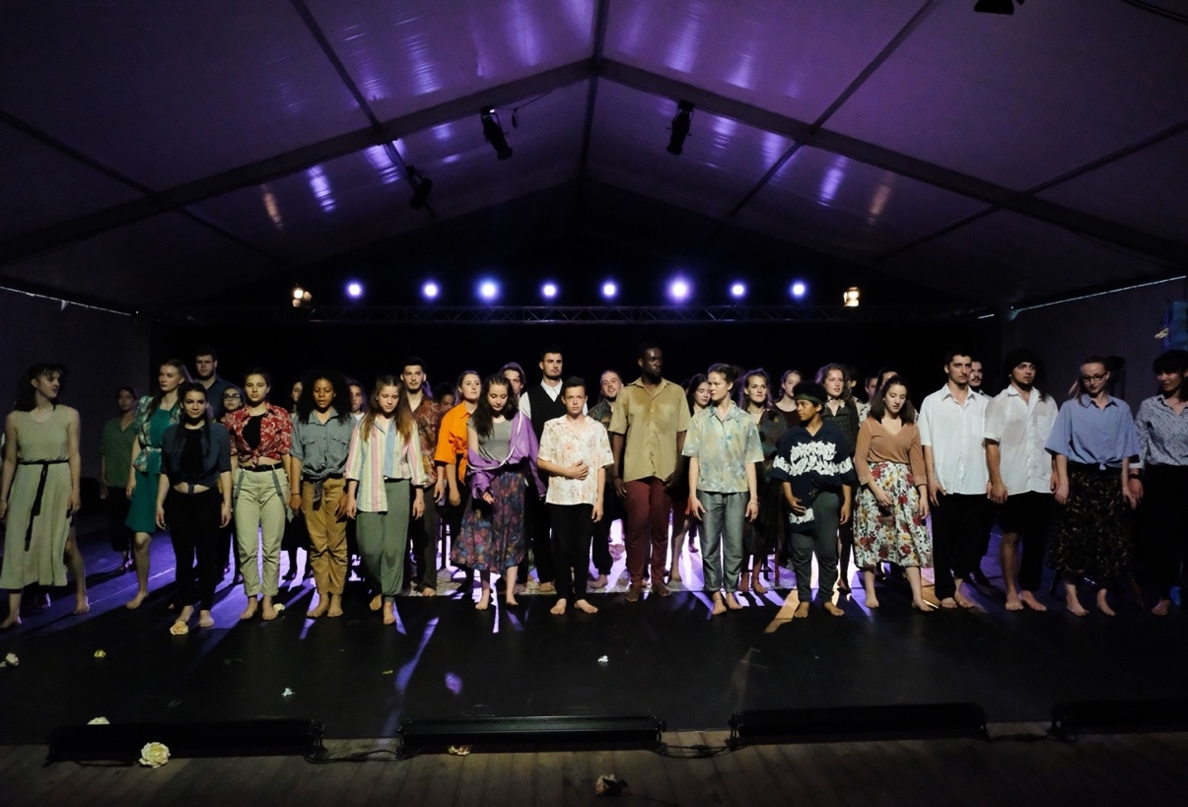
The Ensemble Without Voice at the revival of Passages in Portbou 2019 in Spicheren, France

